"Discover the Magic of Kashmir”
(6N/7D)

This Kashmir tour offers a perfect blend of natural beauty, culture, and relaxation. Begin in Srinagar with local sightseeing, including the famous Mughal Gardens, Shankaracharya Temple, and a glimpse of traditional Kashmiri handicrafts. Travel to the scenic valley of Pahalgam, known for its forests, rivers, and snow-capped mountains.

Continue to Gulmarg, the “Meadow of Flowers,” famous for its ski slopes and optional Gondola ride with breathtaking views. Return to Srinagar for a peaceful stay on a traditional houseboat and enjoy a relaxing Shikara ride on Dal Lake. The tour concludes with departure from Srinagar, leaving you with unforgettable memories of Kashmir.
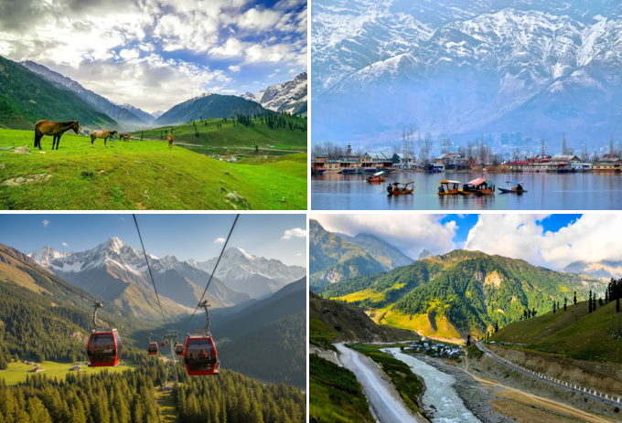

We wish you a happy, safe and unforgettable journey with us

Detailed Itinerary

Day 01: Arrival Srinagar-Local Sightseeing

Upon arrival at Srinagar Airport, meet our representative and transfer to your hotel. After check-in, proceed for a local sightseeing tour covering the beautiful Mughal Gardens – Chashme Shahi, Nishat Bagh, and Shalimar Bagh. Later, visit the sacred Shankaracharya Temple, offering panoramic views of Srinagar and Dal Lake. En route, explore a local handicraft centre renowned for authentic Pashmina shawls, traditional Kashmiri handicrafts, and hand-knotted carpets. Return to the hotel for dinner and an overnight stay in Srinagar.

Day 02: Srinagar – Gulmarg – Srinagar

After breakfast, embark on a full-day excursion to Gulmarg, popularly known as the "Meadow of Flowers." Enjoy a scenic drive through charming villages and lush green landscapes via Tangmarg, the gateway to Gulmarg. Upon arrival, explore the picturesque meadows and visit the famous Gulmarg Golf Course (seasonal), one of the highest golf courses in the world. You may also opt for the thrilling Gondola Cable Car Ride to Apharwat Peak (at an additional cost), offering breathtaking views of the snow-capped Himalayan ranges. In the evening, return to Srinagar for dinner and an overnight stay.

Day 03: Srinagar - Pahalgam (97 Kms | 03 hrs)
After breakfast, check out from the hotel and drive to Pahalgam, one of Kashmir's most picturesque hill stations. En route, visit Pampore, famous for its saffron fields (seasonal), the historic Awantipora Ruins, and Bijbehara, known as the "Breadbasket of Kashmir," while passing through Anantnag. Upon arrival in Pahalgam, check in to your hotel and relax amidst the serene beauty of the Lidder Valley. Enjoy dinner and an overnight stay in Pahalgam.
Day 04: Pahalgam Sightseeing
After breakfast, enjoy a full day exploring the natural beauty of Pahalgam. You may opt to visit the famous Aru Valley, Betaab Valley, and Chandanwari by local union cab (at an additional cost). Adventure enthusiasts can also enjoy a pony ride to Baisaran Valley, popularly known as the "Mini Switzerland of Kashmir." Spend the day amidst lush green meadows, pine forests, and the scenic Lidder River before returning to the hotel for dinner and an overnight stay in Pahalgam.
Day 05: Pahalgam – Doodhpathri – Srinagar
After breakfast, check out from the hotel and drive towards Doodhpathri, one of Kashmir's most beautiful, offbeat destinations, renowned for its lush green meadows, alpine forests, and crystal-clear streams. Spend time soaking in the tranquil surroundings and capturing memorable photographs. Later, continue your journey to Srinagar, where you will check in to your hotel. Enjoy the evening at leisure before dinner and an overnight stay in Srinagar.
Day 06: Srinagar | Houseboat & Shikara Experience
After breakfast, check out from the hotel and check in to a traditional Houseboat on the serene Dal Lake. Later, enjoy a relaxing Shikara Ride, gliding past floating gardens, floating markets, traditional wooden houseboats, and the unique lifestyle of the local communities living on the lake. The rest of the evening is free for shopping at the local markets or exploring the lakeside at your own pace. Return to the houseboat for dinner and an overnight stay on Dal Lake.
Day 07: Srinagar -Departure
After breakfast, check out of the houseboat and transfer to Srinagar Airport for your onward journey. Depart with unforgettable memories of Kashmir's snow-capped mountains, tranquil lakes, lush valleys, and warm hospitality, taking home experiences that will last a lifetime. We wish you a safe journey and look forward to welcoming you again.
Tour ends with unforgettable memories
Destination/Nights | 3* Hotel Name
Srinagar /02N
Pahalgam /02N
Gulmarg /01N
Srinagar/ 01N
HOTELS DETAILS:

Package Cost:

3★ Hotels: Rs. per person (Based on 6 guests – Double Sharing Basis)

Inclusion: -
- Breakfast and Dinner Included.
- 0 DBL Room on sharing based.
- 0 Nights in Srinagar Hotel.
- 0 Night in Pahalgam Hotel.
- 0 Night in Gulmarg Hotel.
- 0 Night in Super Deluxe Houseboat in Srinagar.
- Boat Ride by Shikara on Lake Dal for 01 Hr.
- Assistance on Arrival.
- Welcome Gift on Arrival.
- 02 Bottle Mineral Water Per Day Per Person.
- All Transfers and S.S tours by AC Tempo Traveler [Pick Up Srinagar – Drop at Srinagar]

Exclusions: -
- 5% GST.
- Flight Tickets are not included.
- Guide.
- Extra meal not included or as per the inclusions given above.
- Vehicle not at disposal.
- No extra pickup or drop included for lunch/sightseeing unless otherwise mentioned in the itinerary.

Note:
- Supplement Cost for Aru, Chandanwari & Beetab Valley at Pahalgam Will be Rs. 3000/-Net Per Cab [Sumo/Eeco/Tavera]
- Supplement Cost for Aru, Chandanwari & Beetab Valley at Pahalgam Will be Rs. 3500/-Net Per Cab [Innova/Scorpio/Xylo]
- Supplement Cost for Chained Vehicle from Tangmarg to Reach Gulmarg Will be Rs. 3500/-Net for Both Sides
- Supplement Cost for Cable Car Ride Upto Phase I will be Rs. 950/-Net Per Person and For Both Phase Will be Rs. 2100/-Net Subject to Availability at The Time of Booking)
- Supplement Cost for ESG Will be Rs. 2500/-Net Per Day (Ex Srinagar)

